## Welcome to RecipeSharingPlatform

***RecipeSharingPlatform*** *is a web application designed to inspire and connect home cooks by showcasing delicious and creative recipes from various cuisines. Whether you're looking to try traditional meals or experiment with something new, RecipeSharingPlatform offers a space where users can discover, save, and share their favorite recipes. Logged-in users can create and manage their own Favorites list, while each recipe tracks its popularity through a counter for user engagement.*

## Technological Requirements and Overview

* Use the provided skeleton – [**RecipeSharingPlatform-Skeleton.zip**](http://svn.softuni.org/admin/svn/csharp-web/trunk/May-2025/ASP.NET-Fundamentals/10-Exam-Preparation/Horizons-Skeleton.zip)
* All of the needed packages have been installed.

**The Technological Requirements are ABSOLUTE. If you do not follow them, you will NOT be scored for other Requirements.**

The provided skeleton consists of:

* Web/**Areas/Identity/Pages** – you have to **scaffold Identity** here
* Web/**Controllers** – you should implement the controllers logic here
* **Data/Data** project – you should hold the entity models and RecipeSharingDbContext here
* Web/**Views** – you are **provided with** the needed **views**. Your task is to implement some logic  
   regarding the **logged-in**/**logged-out** user
* Web/**appsettings.json** – don't forget to change your **connection string**
* Web/**Program.cs** – you should fulfill the **security and password requirements** here
* Services**/Core** project – You should implement your **service interfaces** here   
  (example: IEntityService in Contracts folder)
* Web/**ViewModels** project – you should **implement** your **view models** here
* GCommon project – You should hold your **validation constants** here (ValidationConstants.cs)

**NOTE:** You should seed the database with the data provided in advance regarding the **Category** entity. To do this, remove the comments from the block of code in the **protected override void OnModelCreating(ModelBuilder builder)** method of the **DbContext.**

**NOTE: Don't forget to uncomment the code inside the views while you implement your logic.**

Now that you know the **Technological Requirements**, let us see what the **Functional Requirements** are.

## Usage of Services — Mandatory Requirement

All **communication with the database** must go **through** properly implemented **services**.

* The **DbContext** should **not** be used directly inside the controllers.
* Controllers must **call methods from services**, and services will handle the interaction with the DbContext.

Correct **usage of services** will be explicitly **checked during project evaluation**.  
If your controller uses DbContext directly (without using services), you will lose points for **Code Quality.**

## Identity Requirements

You should **scaffold** **Identity** and use the **default** **IdentityUser**.

⚠️ **Important! Delete the Unnecessary DbContext**

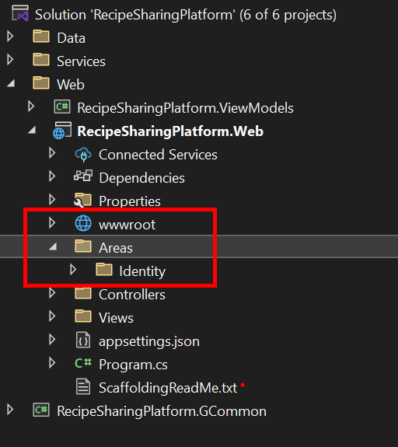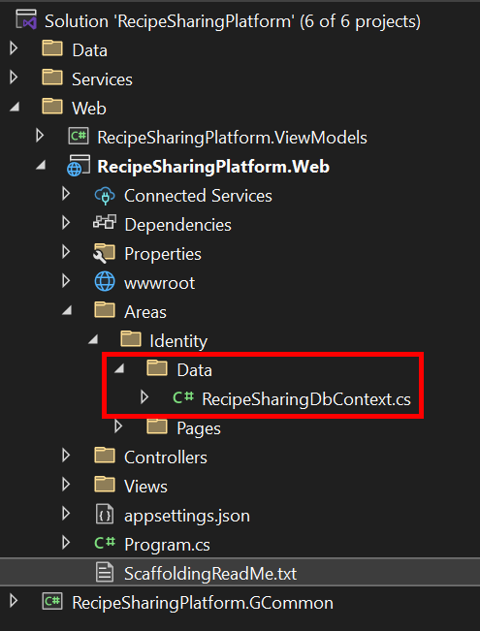

**After you scaffold Identity**, Visual Studio may **automatically generate** a file called RecipeSharingDbContext.cs inside **Areas** > **Identity** > **Data**.  
 **This file is not needed** for our project because we already have our own RecipeSharingDbContext in the main Web project:

* Locate the file **Areas**/**Identity**/**Data**/RecipeSharingDbContext.cs
* **Delete it immediately** to avoid DbContext conflicts in the application.

Remove the unnecessary code from the **Login.cshtml** and **Register.cshtml** files and leave only the needed code for the app to function correctly.

**NOTE: Don't worry about the views' style – once you scaffold Identity and remove the unnecessary code, the** [**Login**](#_Login_Page_(logged-out) **and** [**Register**](#_Register_Page_(logged-out) **pages should look like the ones shown below. Don't add any classes to the views of those two pages!**

The **password** requirements for the **IdentityUser** are the following:

* Require confirmed account: **false**
* Require digits: **false**
* Require non-alphanumeric characters: **false**
* Required uppercase letters: **false**
* Required lowercase letters: **false**

## Database Requirements

The **Database** of **RecipeSharingPlatform**:

### Recipe

* Has Id – a unique **integer, Primary Key**
* Has Title – a string with **min** length **3** and **max** length **80** (**required**)
* Has Instructions – string with **min** length **10** and **max** length **250** (**required**)
* Has **ImageUrl** – nullable string (**not required**)
* Has AuthorId – string (**required**)
* Has Author – IdentityUser (**required**)
* Has CreatedOn – DateTime with format "**dd-MM-yyyy**" (**required**)
  + The **DateTime** format is only recommended
* Has CategoryId – **integer, foreign key (required)**
* Has Category – Category (**required**)
* Has IsDeleted – bool **(default value == false)**
* Has **UsersRecipes** – a collection of type **UserRecipe**

### Category

* Has Id – a unique **integer, Primary Key**
* Has Name – a string with min length **3** and max length **20** (**required**)
* Has **Recipes** – a collection of type **Recipe**

### UserRecipe

* Has UserId – string, PrimaryKey, foreign key (**required**)
* Has User – IdentityUser
* Has RecipeId – integer, PrimaryKey, foreign key (**required**)
* Has Recipe – Recipe

Implement the entities with the **correct datatypes** and their **relations**.

**Feel free to use the new syntax for the realization of the many-to-many relation without a mapping table.**

## Page Requirements

### Index Page (logged-out user)

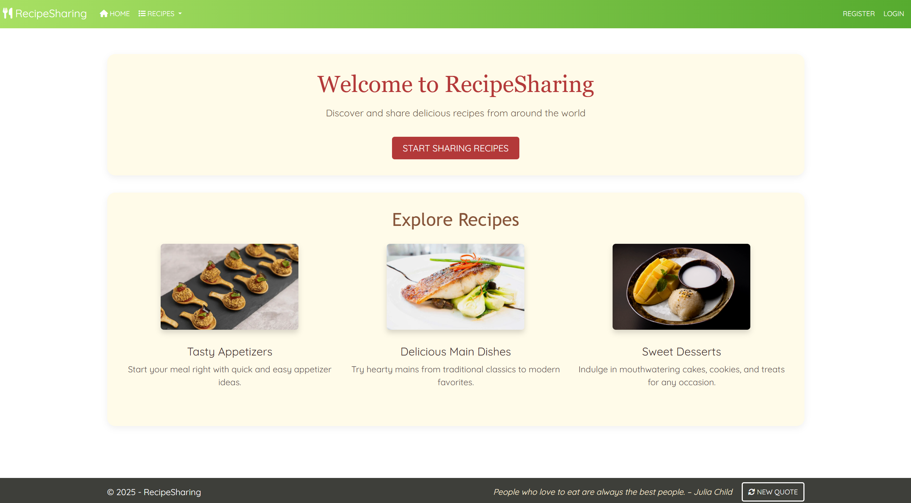

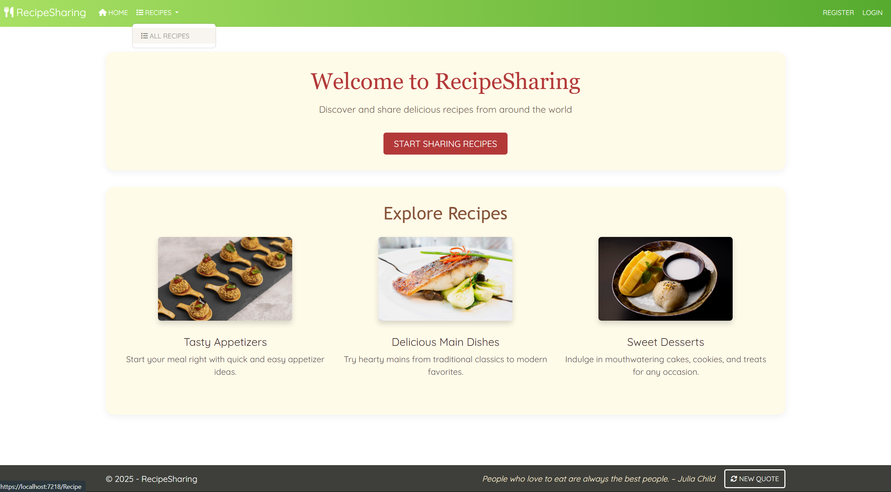

### Index Page (logged-in user)

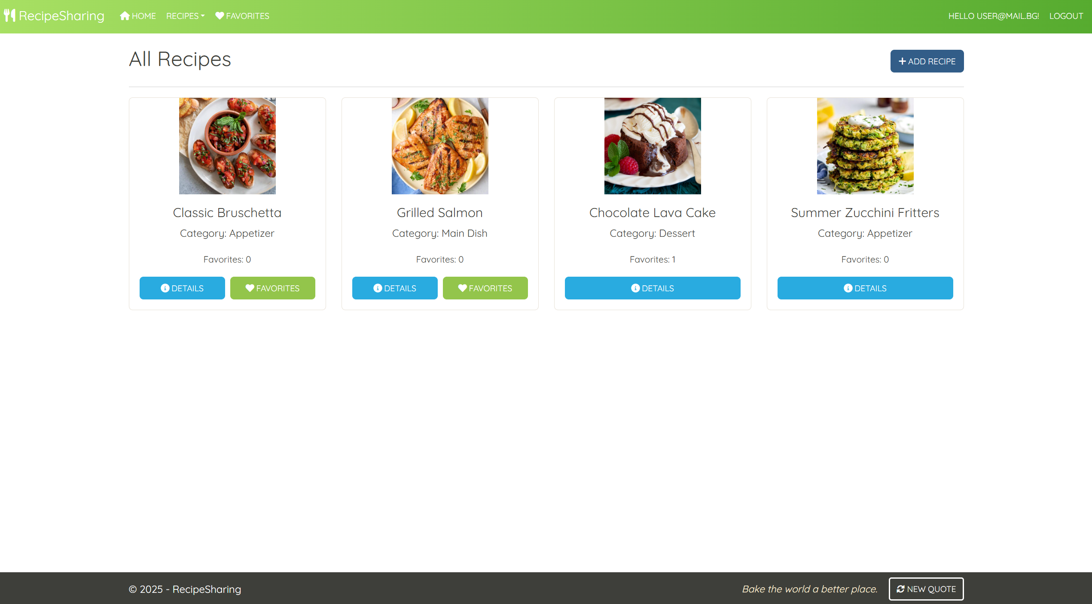

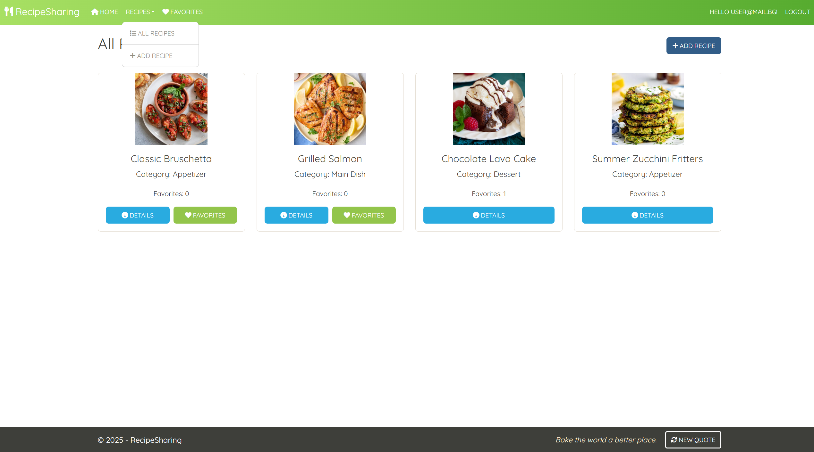

**Note: The Recipe Index Page** will have **different behavior** for **logged-in** and **not-logged-in** users. Also, **different recipes' cards** will behave differently for **authors** and **non-authors**.

### /Recipe/Index (logged-out user)

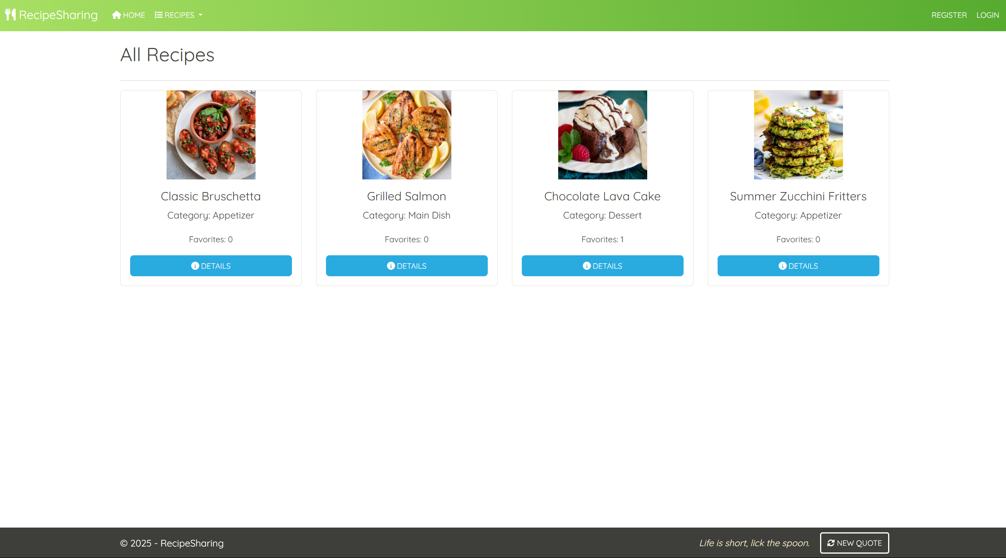

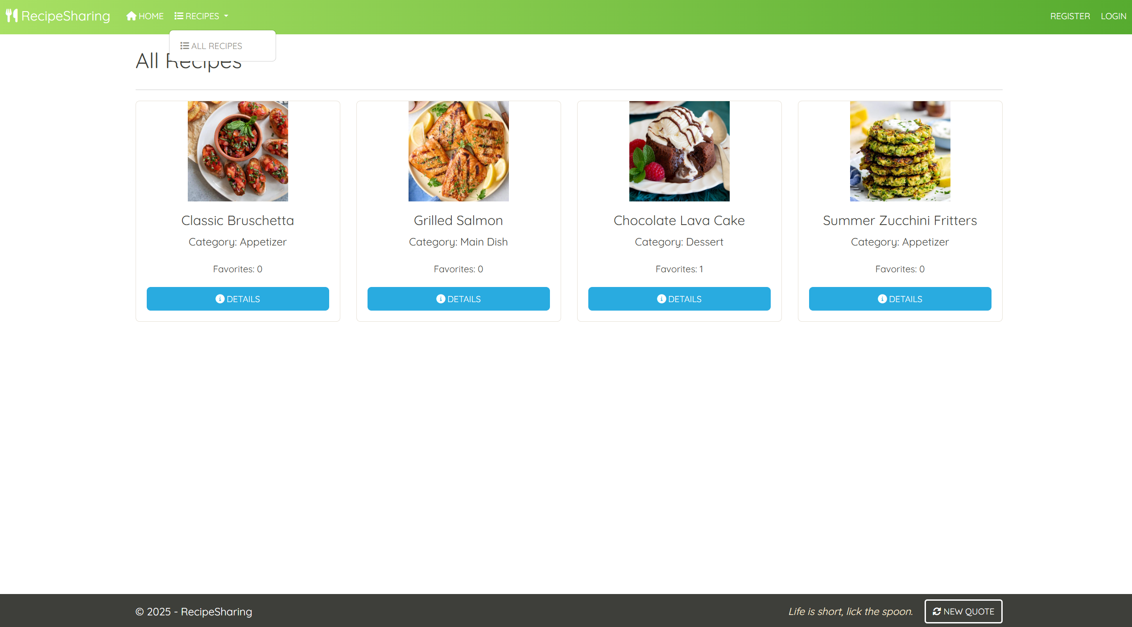

**NOTE**: If the current user is not **logged in** they will be still able to access the **/Recipe/Index** page

### Login Page (logged-out user)

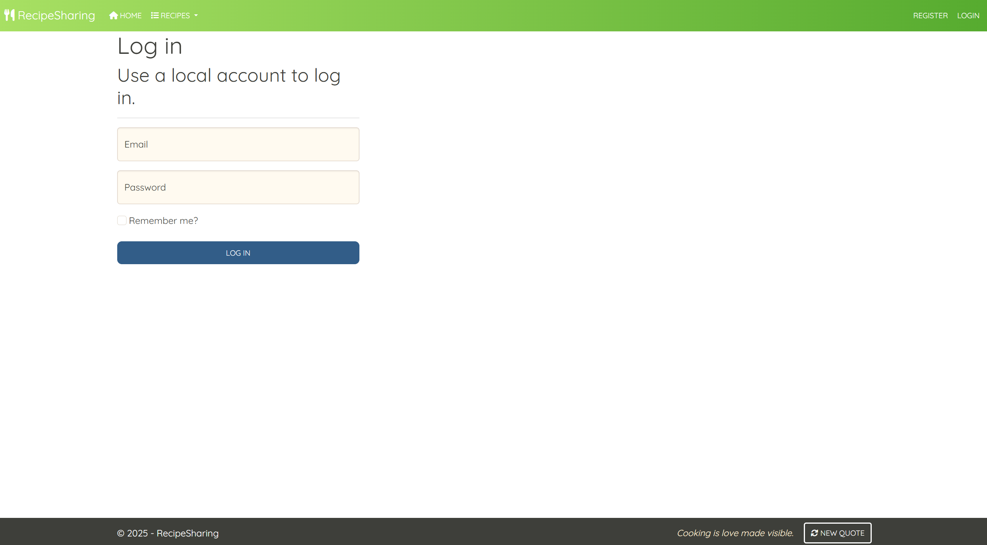

### Register Page (logged-out user)

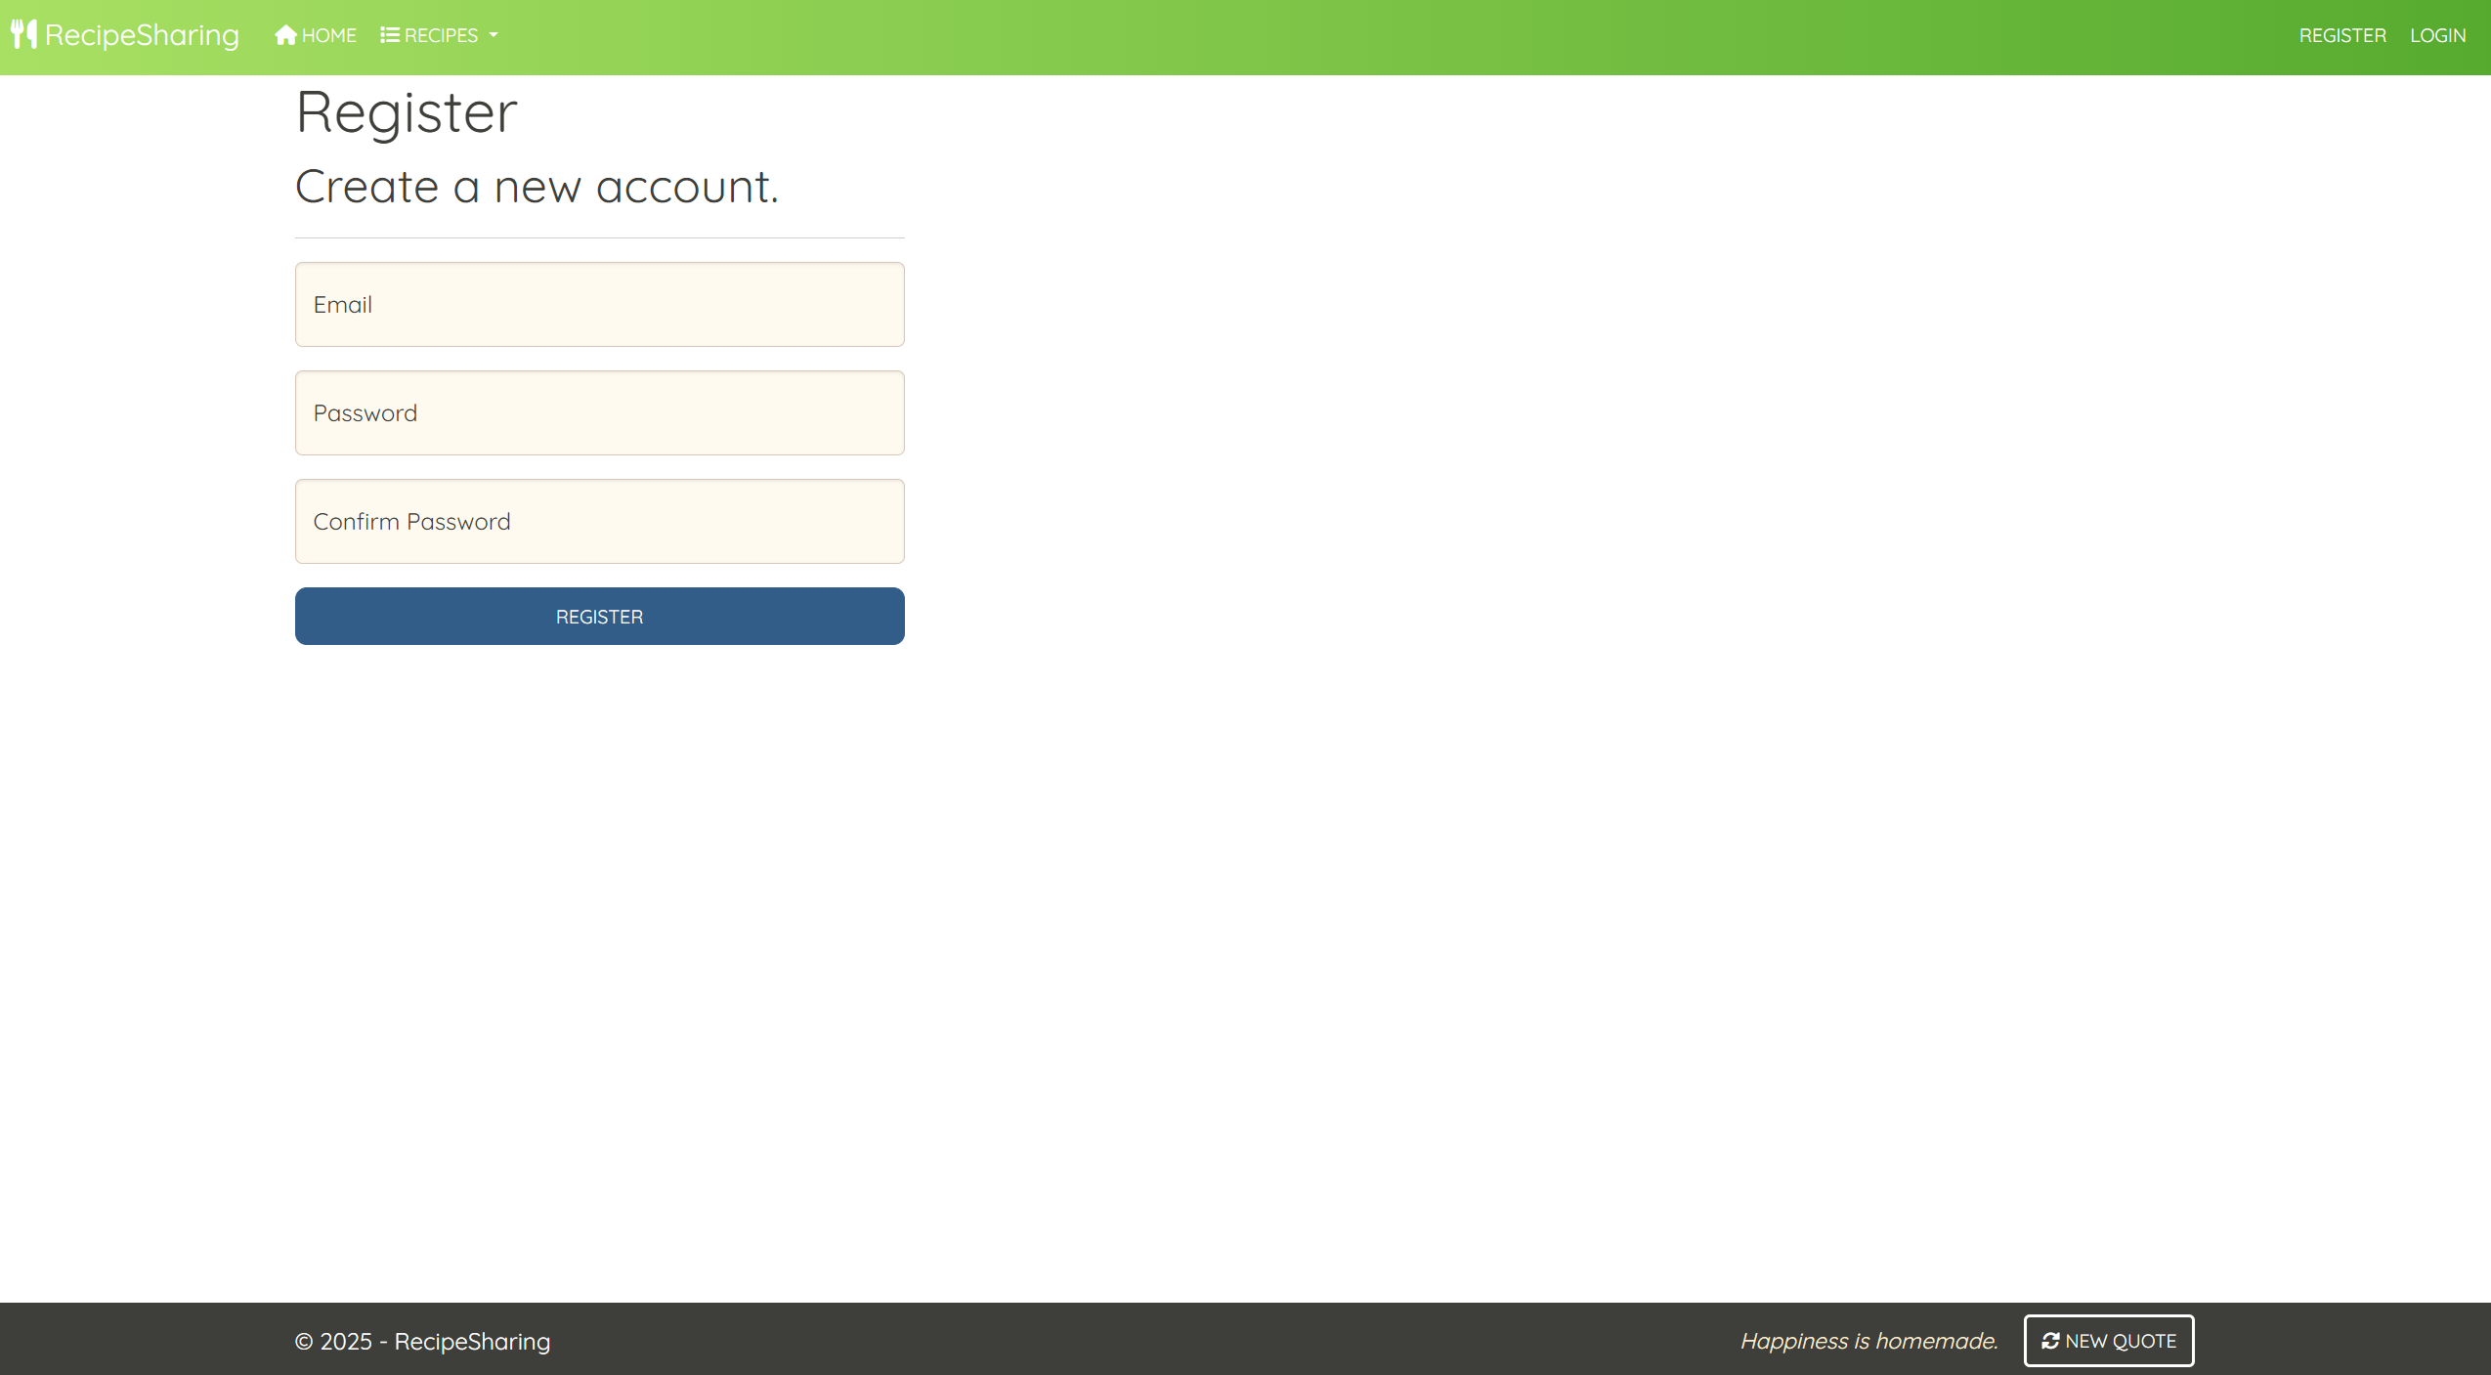

**Note: The Register Page** should be **accessible** from the **"Start Sharing Recipes" button** from the Index Page for  
(logged-out user)

### /Recipe/Create (logged-in user)

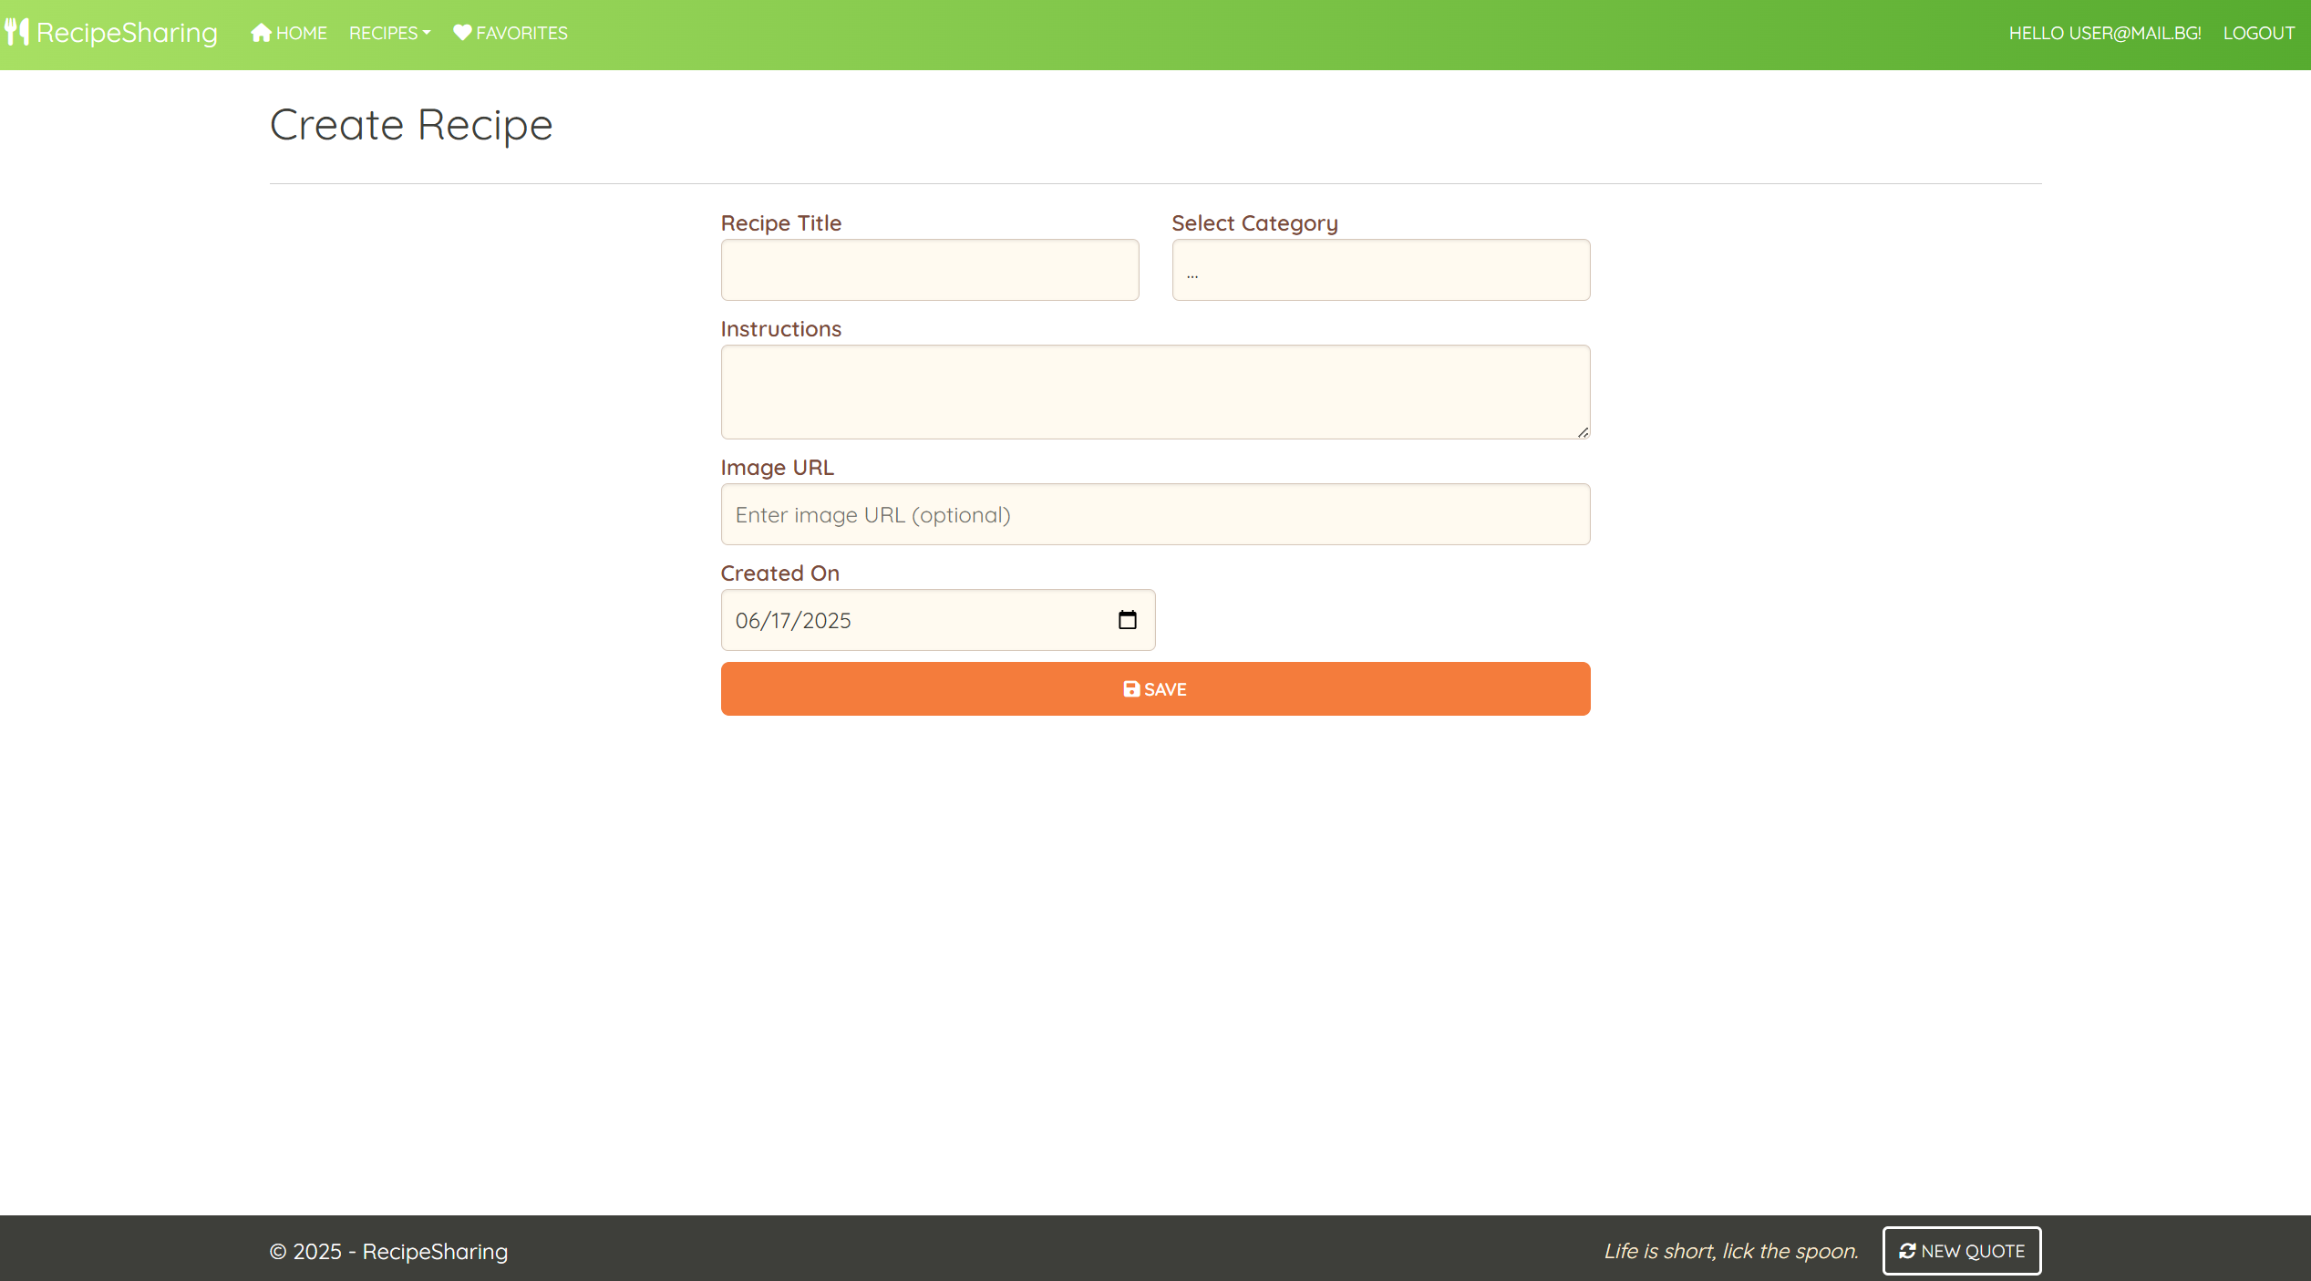

**NOTE:** the **DateTime** format is recommended, if you are having trouble with the one in the image, you are **free** to use **another** one.

### /Recipe/Favorites (logged-in user)

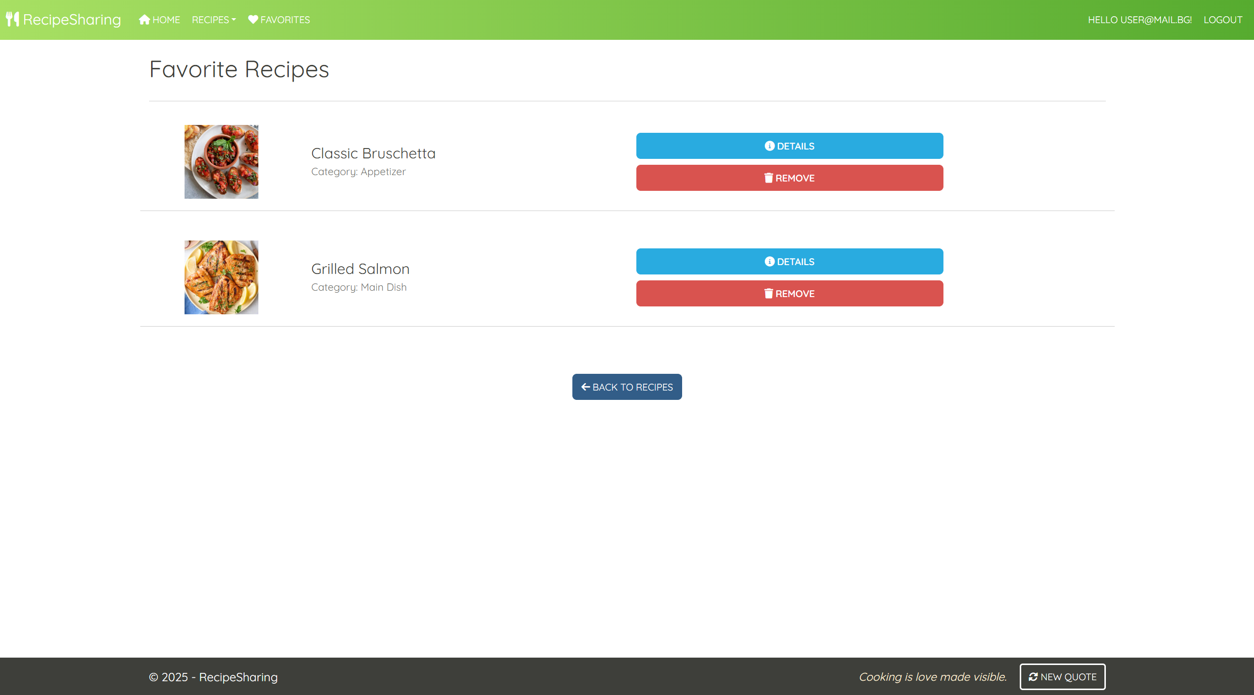

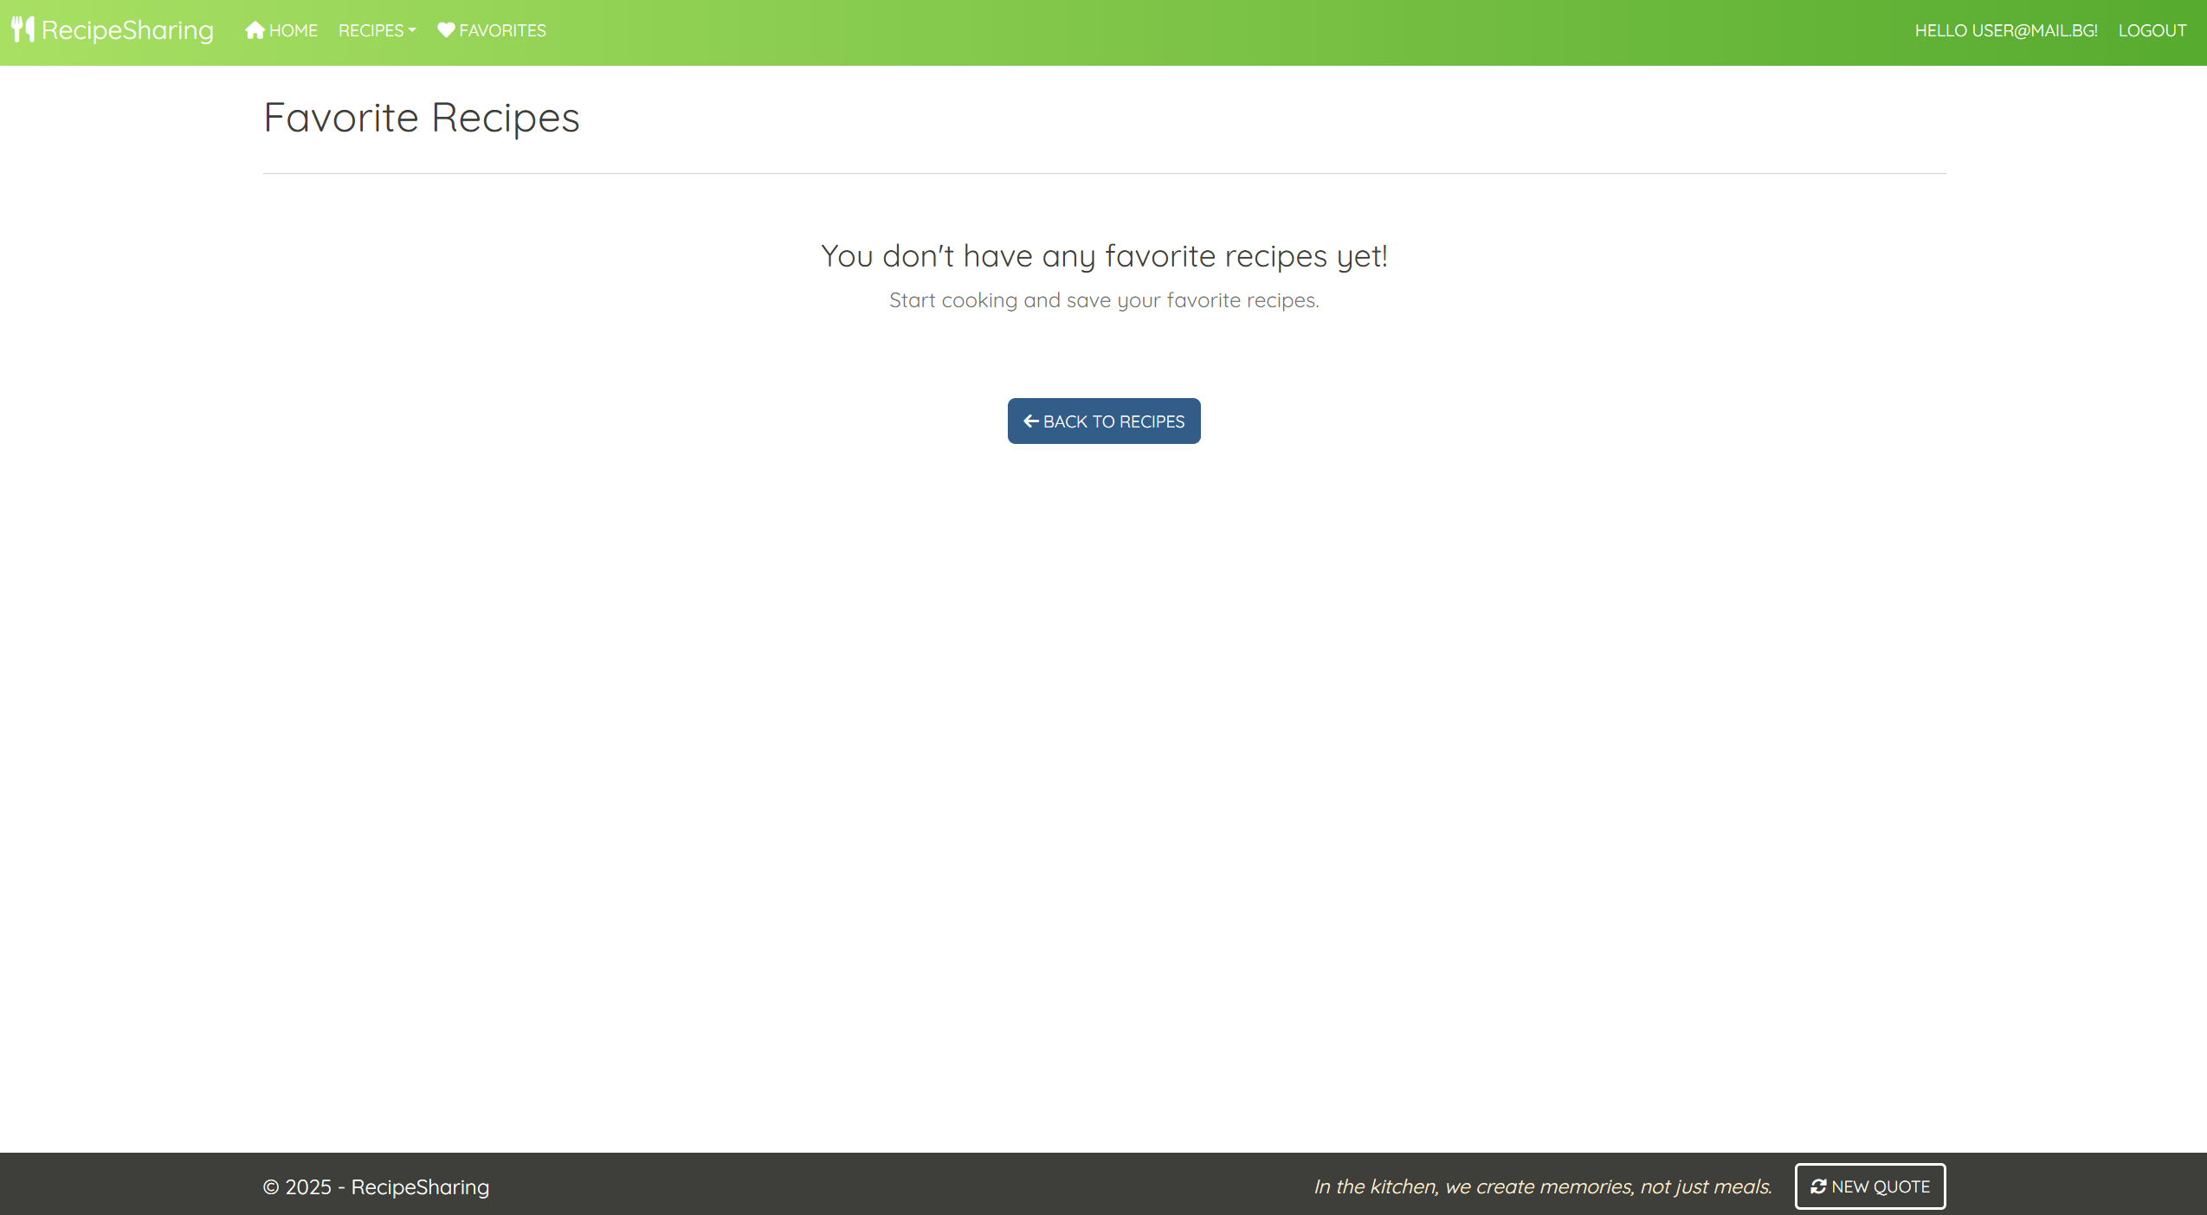

**NOTE**:

* When a user **removes a favorite recipe** from the list, the application **should update the view** **without redirecting the user**
* If **no favorites are left after a removal action**, the **user should remain on the same page** and see the following message: "You don't have any favorite recipes yet!"

**Recipe/Details/{id} (logged-in user, author of a recipe)**

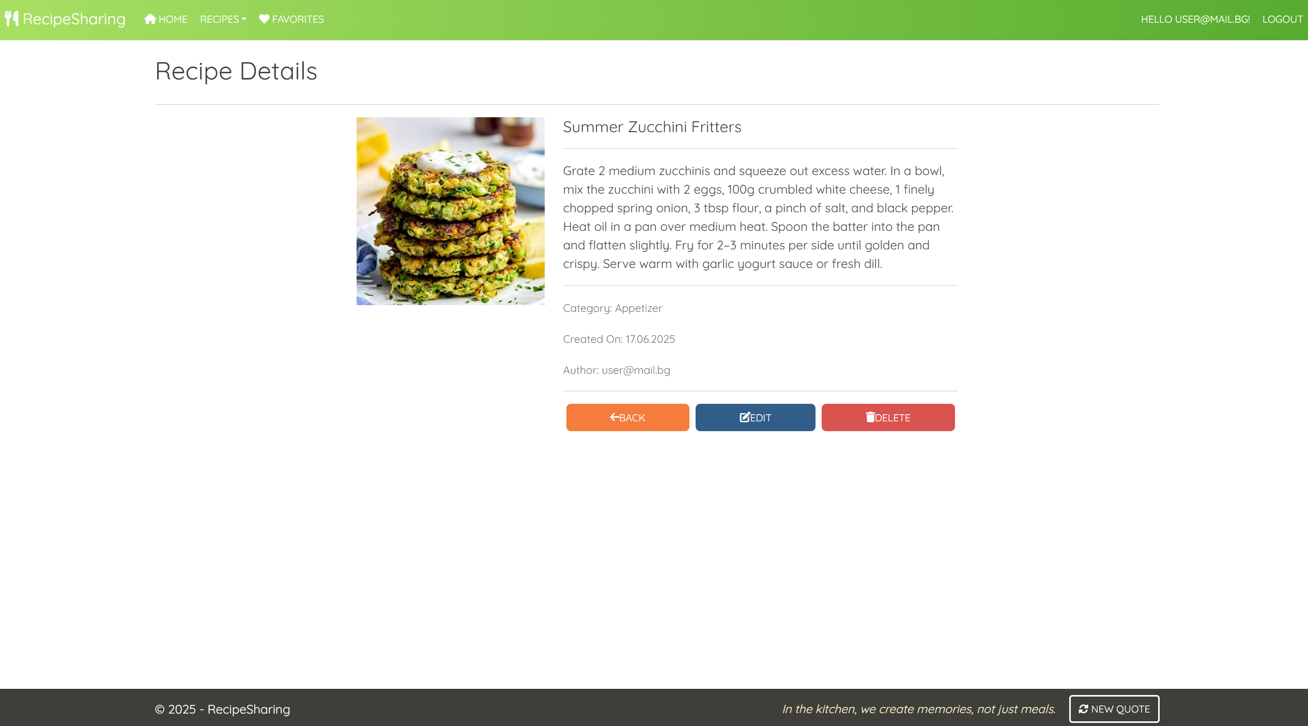

**Recipe/Details/{id} (logged-in user, not-author of a recipe, the recipe is not added to favorites)**

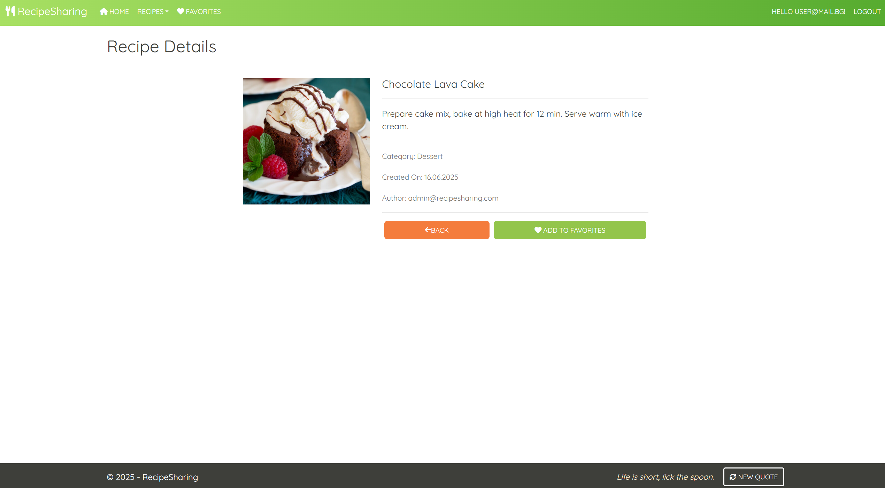

**Recipe/Details/{id} (logged-in user, not-author of a recipe, the recipe is already added to favorites)**

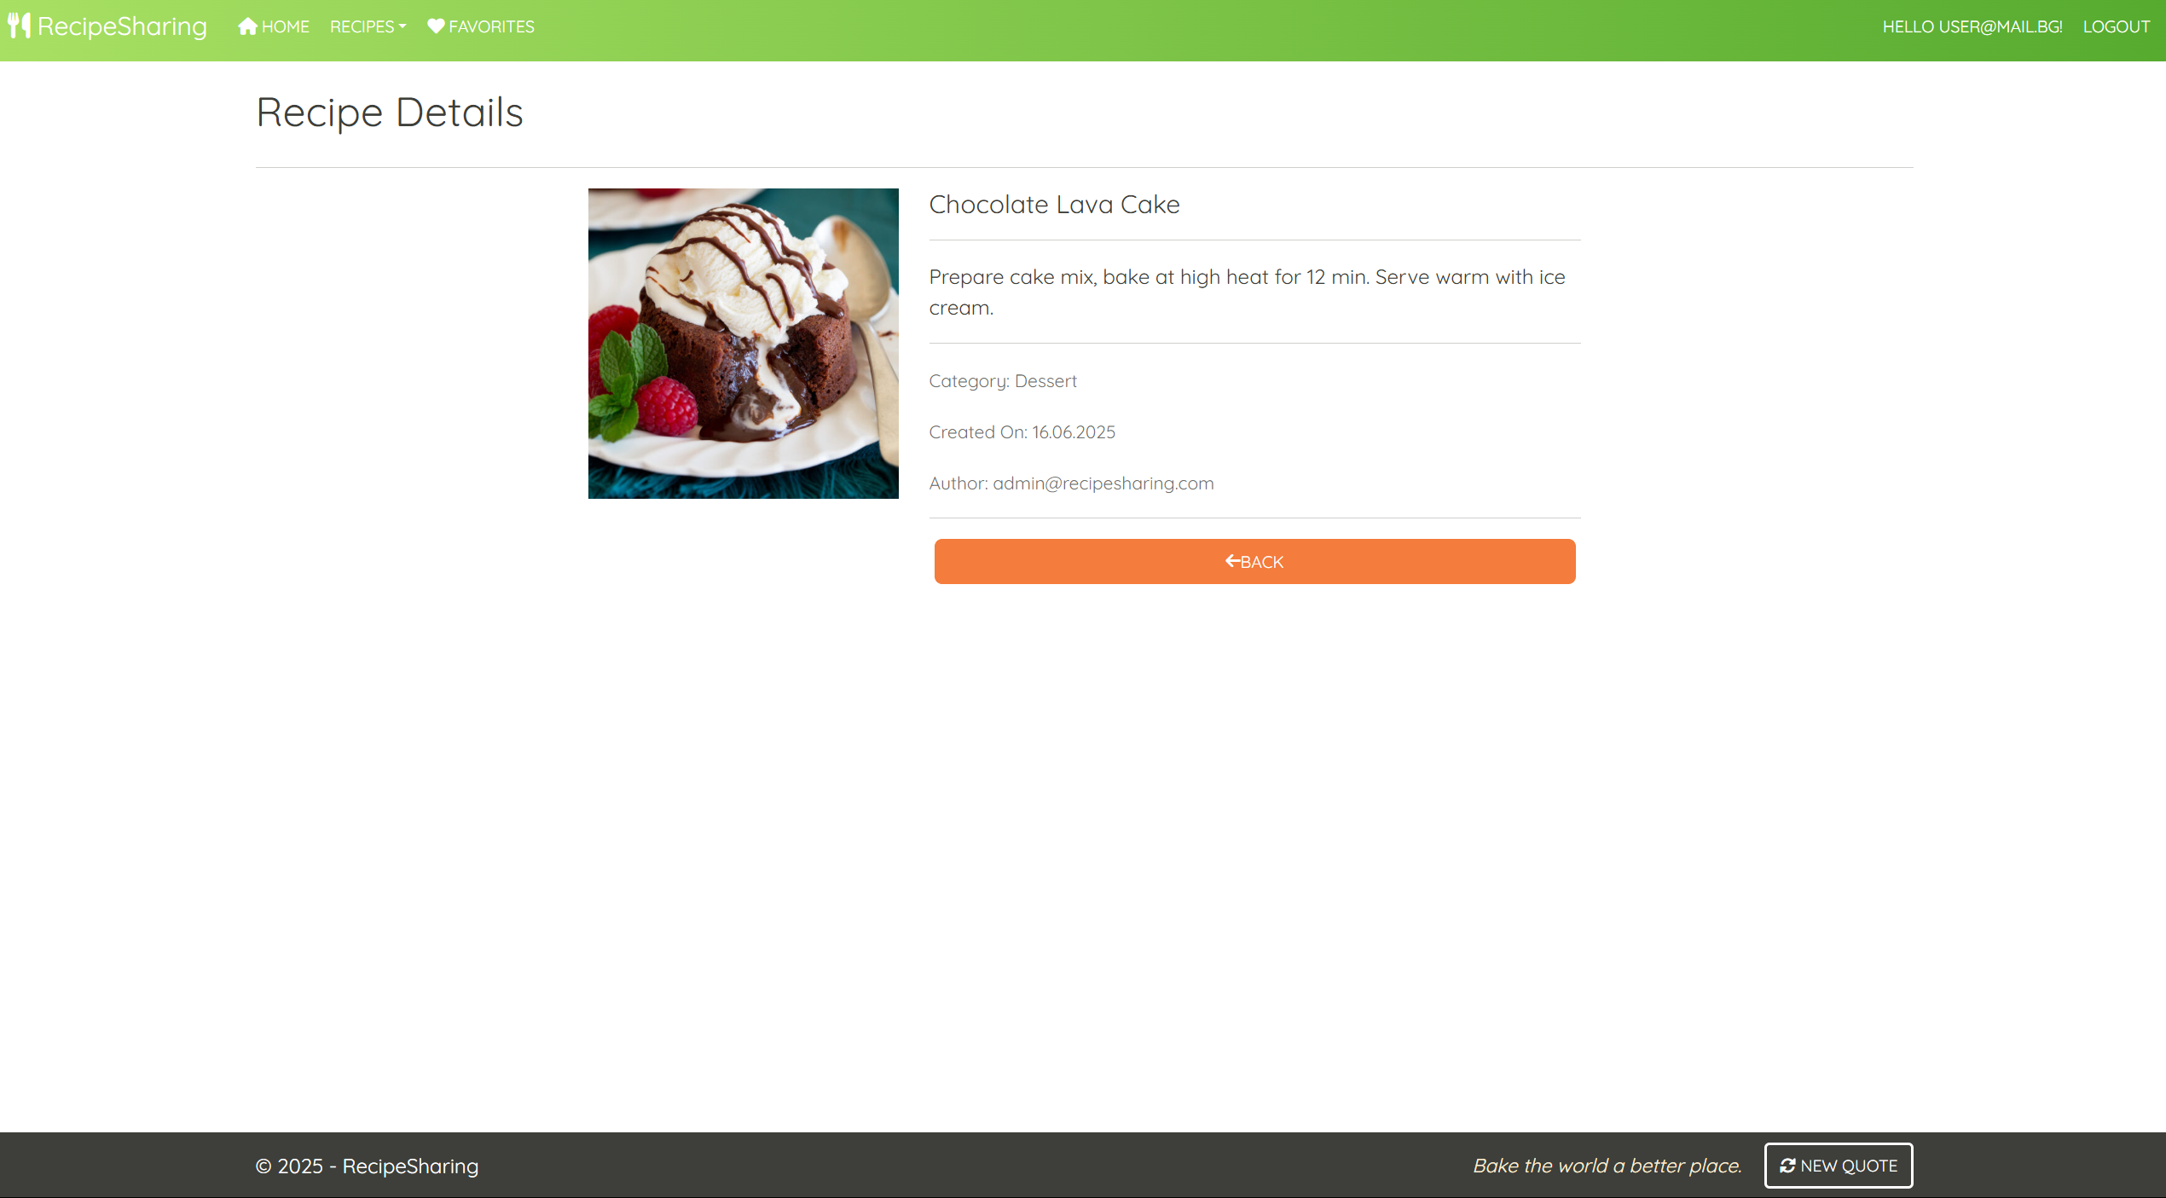

**Recipe/Details/{id} (guest user)**

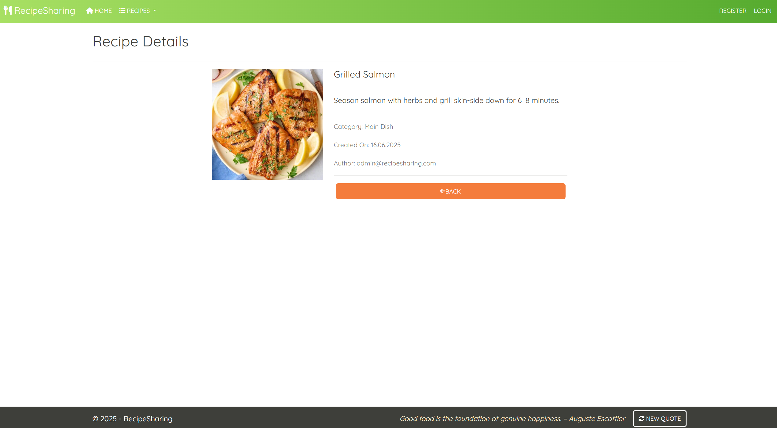

**NOTE**:

* If the **currently logged-in user is the author of the recipe**, the **"Delete"** and **"Edit"** buttons should be **visible**, allowing them full access to the recipe functionalities.
* If the **logged-in user is** **not the author** of the recipe, the **"Delete"** and **"Edit"** buttons should **NOT** be **visible**. The **"Favorites"** button should be **visible**. This ensures that the **recipe author** and   
  **Not-author-users** have different application functionalities access.
* Guests (**unauthenticated users**) should be able to **access the recipe's details page** but **won't have access to actions** like **adding to favorites**, **editing**, or **deleting** a recipe.

### /Recipe/Save?id={id} (logged-in user)

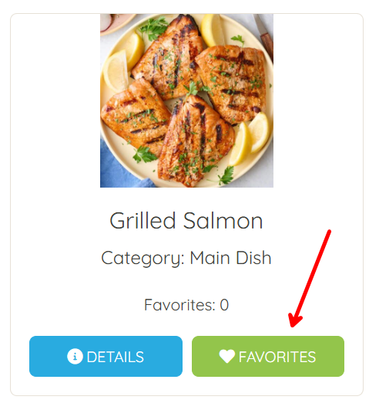

This **feature is accessible by the Favorites button** in every recipe card and **adds the selected recipe to the user's Favorites collection**. If the recipe is **already in the collection**, it **should not be added again**. If the **addition is successful**, the users will **remain on the current page**, (either **Recipe/Index** or **Recipe/Details**) rather than being redirected to the favorites page.

### /Recipe/Remove?id={id} (logged-in user)

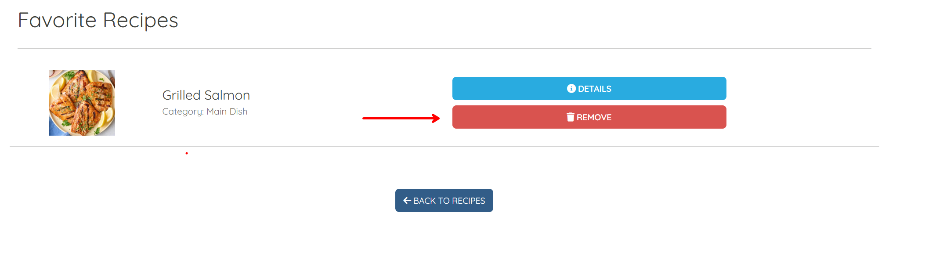

This **feature is accessible by the Remove button** in the "**/Recipes/Favorites**" page and **removes the selected recipe** from the user's **favorites collection**. If the **removal is successful**, the user will **remain on the current page** "**/Recipe/Favorites**" page.

**NOTE**: The templates should look **EXACTLY** as shown above.

**NOTE:** the **DateTime** format is recommended, if you are having trouble with the one in the image, you are **free** to use **another** one.

**Recipe/Delete/{id} (logged-in user, author of a recipe)**

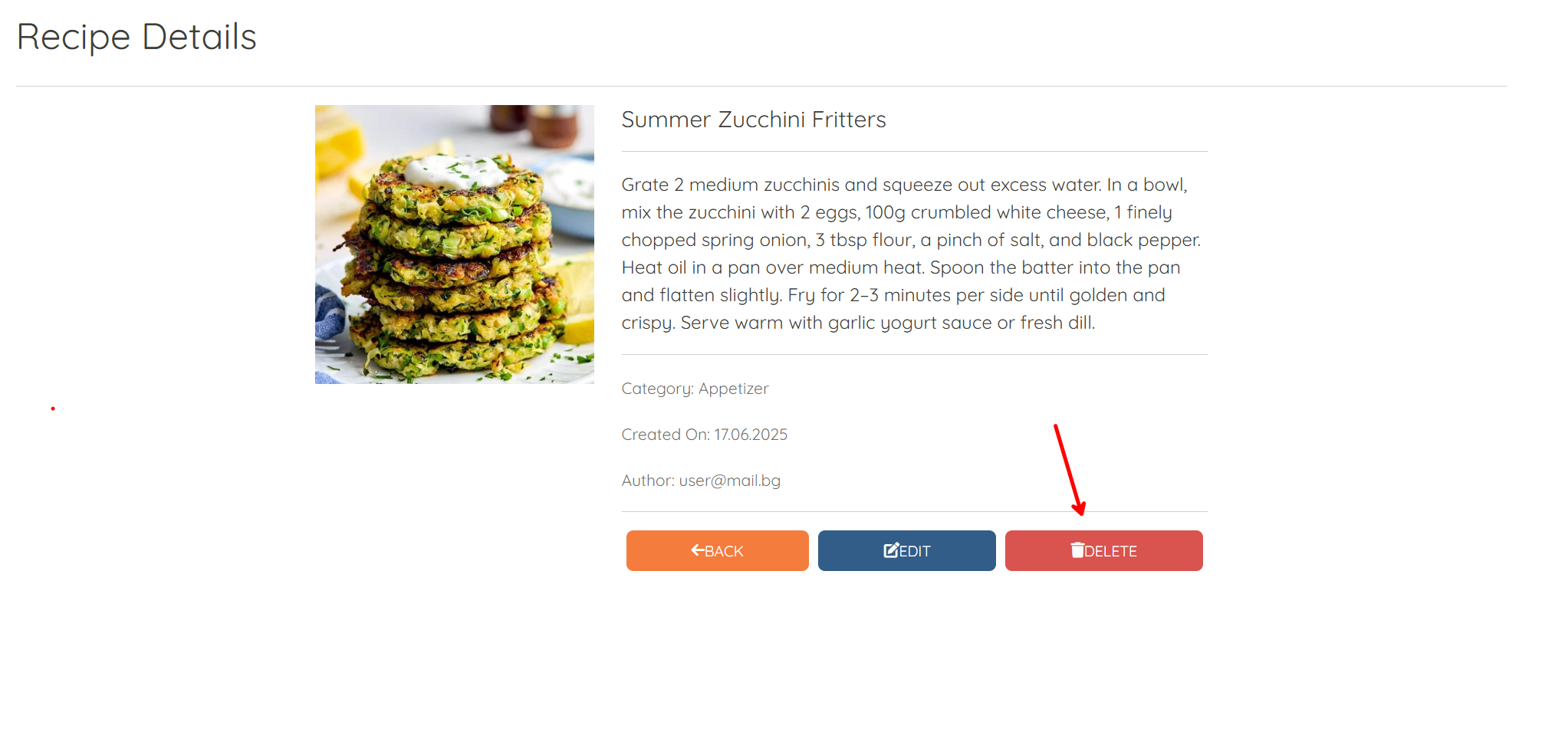

When a **logged-in user** who is the **author of a recipe** accesses this page, they can initiate the deletion of the recipe. This process uses **soft delete functionality**, meaning the **recipe will remain in the database** but will **no longer appear in recipe listings** or be accessible to users.

**Recipe/ConfirmDelete/{id} (logged-in user, author of a recipe)**

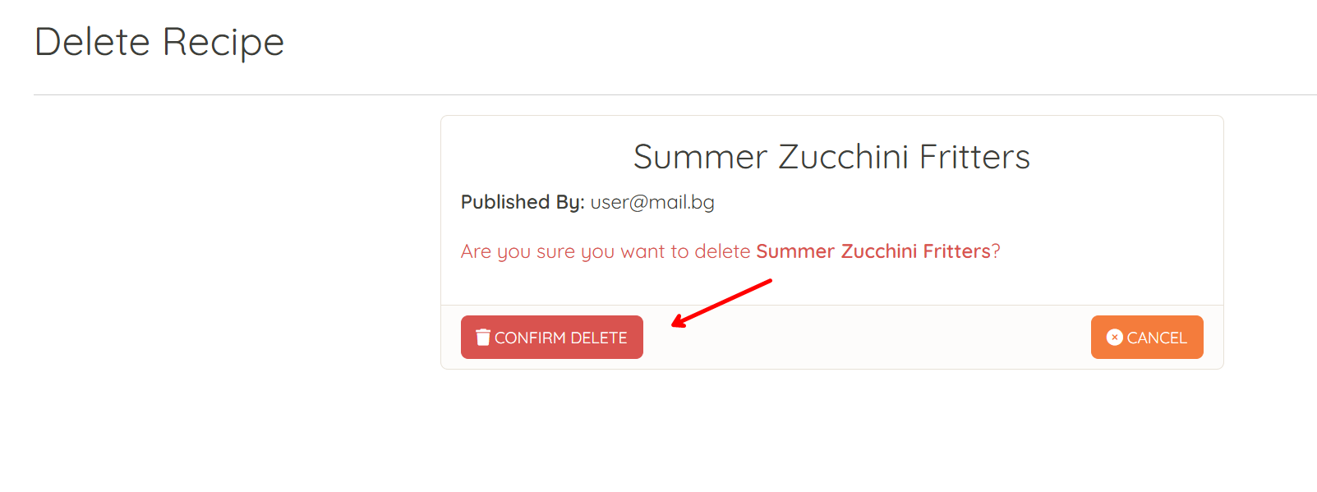

**After confirming the deletion**, the author will be **redirected to the Recipe controller's Index action**. This operation is **one-directional and irreversible through the user interface**. Once deleted, the **recipe will not be displayed** in the application unless it is manually restored via the database.

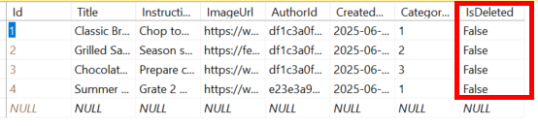

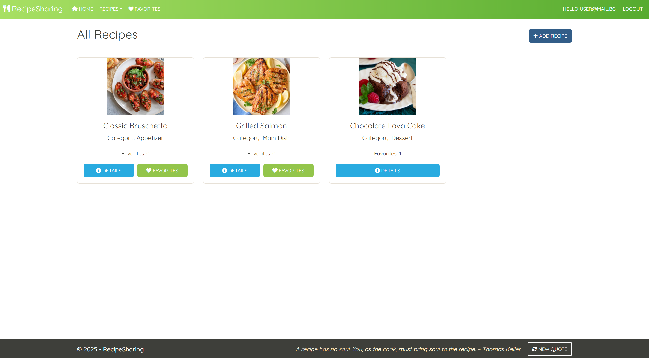

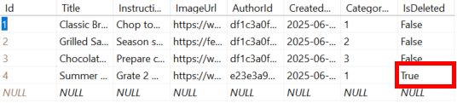

**Cancel Button Behavior**

The **Cancel button** in the **Delete Recipe** view is configured to **return the user to the Details page** of the recipe they chose not to delete.

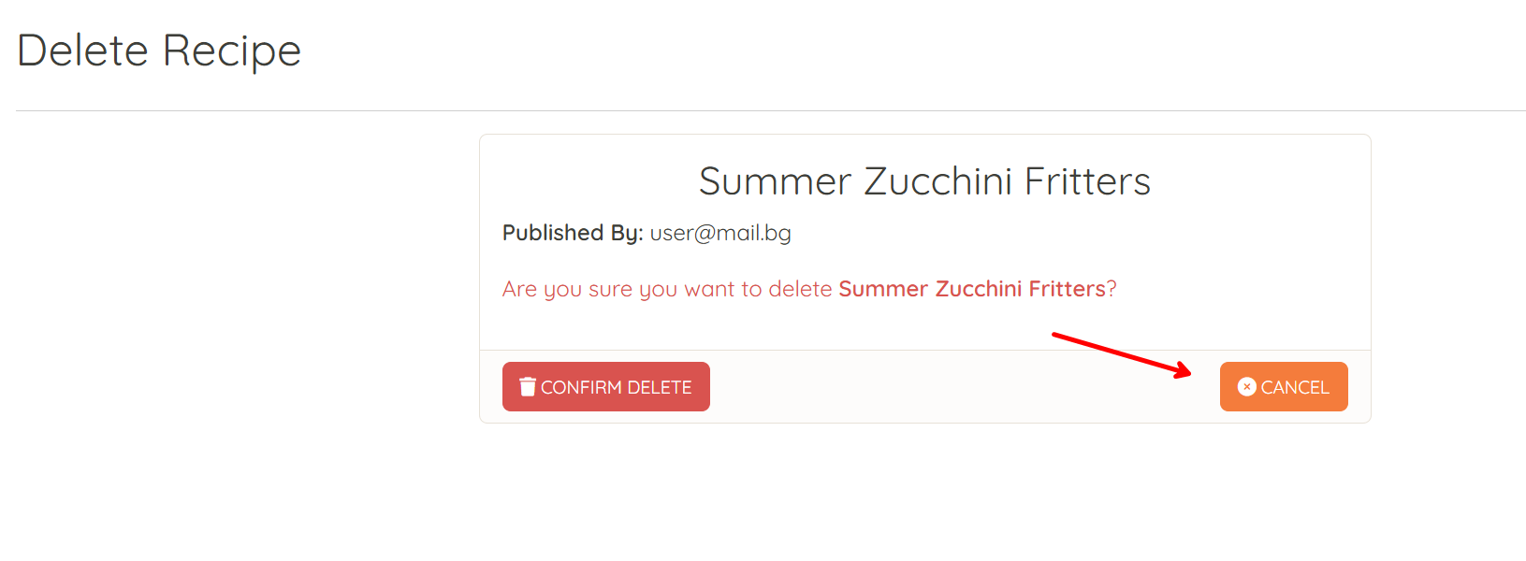

## Functionality

The functionality of the **RecipeSharingPlatform** is a very simple application.

### Users

Guests can Register, Login and view the **Home Page**, Index Page and Details Page.

**Logged-in users** can **publish** recipes and **edit** recipes **they have created**.

Users (**guest-users + logged-in-users**) can **view all published recipes**, including those by other users, on the **Home Page** (**/Recipe/Index**).

If the **user is the author of the recipe**

* They **can't see** the **[Favorites]** button
* They can see the **[Details]** button

If the user is **not the author** of the recipe, they can only add the recipe to their collection [**Favorites**].

### Recipe

Recipe can be **added** by **logged-in-**users. All added recipes are visualized on the Home Page (/Recipe/Index) with **some** of their associated **information**.

Recipes are visualized on the Index Page (/Recipe/Index) with **one or two buttons**:

* If the user **IS NOT** the **author** of the recipe – **[Details][Favorites]**
* If the user **IS** the **author** of the recipe – **[Details]**

The **[Favorites]** button adds the recipe to the user's collection of favorite recipes (Favorites) **unless it is already added**.

The **[Details]** button displays a new page with the full information for the selected recipe. The actions and buttons displayed on this page will vary depending on the user's identity and role:

* **Guest (Not Logged In)**:  
  The user can see the **full details of the recipe** but will **not be able to add to favorites**, **edit**, or **delete** the recipe. No action buttons (**[Favorites]**, **[Edit]**, **[Delete]**) will be shown.
* **Logged-in User (Not the Author)**:  
  The user will **see the full details** of the recipe and will **have access to the [Favorites]** button, allowing them to **add the recipe to their collection of favorite recipes** (if it has not already been added). The **[Edit]** and **[Delete]** buttons will not be displayed as they are **not the author** of the recipe.
* **Author of the Recipe**:  
  The author will have **full access to the recipe's details** and will be able to see both the **[Edit]** and **[Delete]** buttons. However, the **[Favorites]** button will not be displayed since the author cannot add their own recipe.

The **[Edit]** button displays a new page with a form, filled in with **all** of the **info** for the **selected** **recipe**. Users can **change this info and save it**.

Usershave a Favorites page where only the recipesthey have selected as favorites are displayed.

* The **[Remove]** button **removes** the selected **recipe** from the **user's** collection of **favorite recipes**.

### Redirections

* Upon successful Login of an **IdentityUser**, you should be redirected to the /Recipe/Index
* Upon successfully Publishing a Recipe, you should be redirected to the /Recipe/Index
* Upon successfully Adding a **Recipe** to the **User's Favorites**, should be redirected to /Recipe/Index
* Upon successful **Editing** of a **Recipe,** you should be redirected to **/Recipe/****Details/{product_id}**
* Upon successful Removal of a **Recipe** from the **User's Favorites**, should be redirected to the /Recipe/Favorites
* If a User **adds** a recipe to the **Favorites** collection, the **[Favorites]** button **disappears**, and the user should not be able to duplicate recipes in the **User's Favorites.**
* Upon successful Logout of a User, you should be redirected to the Home Page
* If any of the **validations** in the POST forms **don't pass**, **redirect** to the **same page** (**reload/refresh** it)

## Security

The Security section mainly describes access requirements.

**Users-only** pages (Add, Edit, Favorites, Delete)

Configurations about which users can access specific functionalities and pages:

* Guest (not logged-in) users can access the Home page, **Recipe Index** page, and **Recipe Details** page
* Guest (not logged-in) users can access the Login page
* Guest (not logged-in) users can access the Register page
* Guests (not logged in) cannot access Users-only pages
* Users (logged in) cannot access Home page
* Users (logged in) can access the Recipe/Add page and functionality
* Users (logged in) can access the Recipe/Edit page and functionality
* Users (logged in) can access theRecipe**/Favorites** page
* Users (logged in) can access Logout functionality
* Users (logged in) cannot access the Recipe/Edit page of a recipe that has another user as a author
* Users (logged in) cannot access the Recipe/Delete page of a recipe that has another user as a author

## Code Quality

* Make sure you provide the best architecture possible. Structure your code into different classes, and follow the principles of high-quality code (**SOLID**).
* All interaction with the database **must go through properly implemented services**.
* You will be scored for the Code Quality and Architecture of your project.

## Scoring

### Identity Requirements – 5 points

### Database Requirements – 10 points

### Template Requirements – 10 points

### Functionality – 50 points

### Security – 5 points

### Code Quality – 10 points

### Data Validation – 10 points